Week_1 Report:

1. Identify Active Network Interface:
Command: ip a
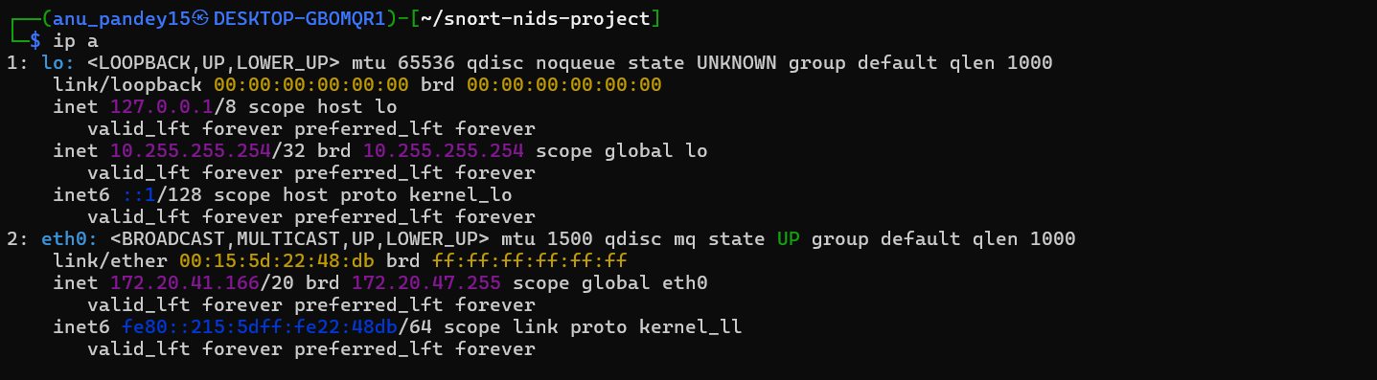
2. Configure Configure Snort with monitored IP range:
Edit Snort configuration file: sudo nano /etc/snort/snort.lua
Set: HOME_NET = '192.168.1.0/24'

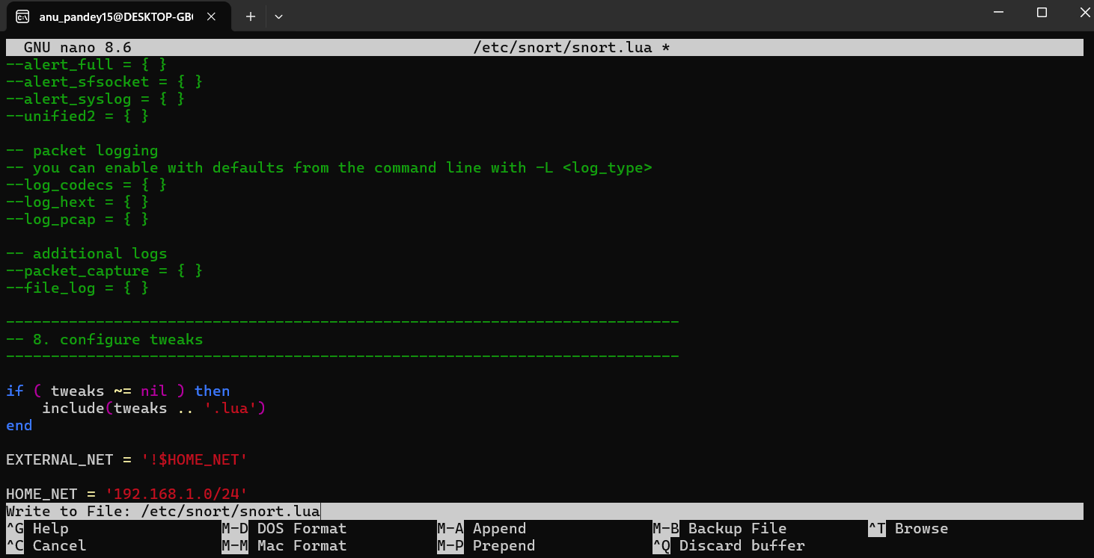

3. Run Snort in detection mode &
4. Monitor live traffic and alerts
